First Impressions: 500 years of printing in St Albans

On your way into the gallery

St Albans City & District Council Crest
This crest usually hangs in the St Albans City & District Council Chamber. On the left of the crest is the figure of a printer holding an ink ball or dabber. This tool was used in printing to apply ink to a plate or type. The printer represents “John Insomuch”, the name often given to the first printer in St Albans. He was included when the figures were added in the 1970s to remind residents of the important role the print industry has played in the history of St Albans.
The crest also features a baron holding a copy of the Magna Carta, as a meeting which led to the Magna Carta was held in St Albans. The Abbot serves as a reminder that St Albans Abbey once ruled the town.

Introduction to the Exhibition

William Caxton first introduced printing to England in 1476. He set up his first printing shop in London, but by 1479 St Albans had its own printing press, the third in the country.
St Albans Abbey had a reputation as a centre of excellence in the art of writing and illustrating books. This tradition began under the first Norman abbot Paul de Caen in around 1100, who founded a scriptorium, a place where the monks would have created handwritten and illuminated manuscripts. Over the following 400 years the abbey produced many documents and manuscripts including the St Albans Psalter and the Gesta Abbatum Monasterii Santi Albani that covered the history of the abbots of St Albans since 793. As such, it is no surprise that St Albans Abbey was at the forefront of those eager to adopt new printing technology soon after its introduction to England.
St Albans has been part of the story of print in England from those early days. A journey of changing technology, changing design and an industry that grew from a single press in the Abbey Gateway to multiple printing companies working across the City.
First display case
Manicule
This symbol is a punctuation mark, called an index. Mmanicule come from the Latin root manicula meaning “little hand” or fist. Other names for the symbol include printer’s fist, bishop’s fist, digit, mutton-fist, hand, hand director, pointer and pointing hand.

Manuscript leaf from St Albans Abbey
St Albans Cathedral Archive
This reproduction is of a page from an illuminated Bible. The real manuscript page was written and illuminated in Paris in around 1330 and given to St Albans Abbey by Abbot Michael de Mentmore (Abbot of St Albans 1335–1349).
St Albans Abbey had a large library of manuscripts, many of which were created by the monks there. Before the use of print became wide spread every book had to be copied by hand which took a long time. Hand-copying also meant that no two copies of a book were identical and mistakes could be made in the copying process.

Confessio Amantis, by John Gower
This page was printed by William Caxton in 1483. William Caxton first became interested in printing when he saw the new presses in Cologne. In 1476 he set up his first printing press in Westminster. The first book known to be printed in England is Caxton’s edition of The Caterbury Tales by Geoffrey Chaucer.
This page is from Confessio Amantis by English poet John Gower. Caxton’s print edition brought his poetry to a much wider audience.

Changing Technology

The first recorded printing press in Europe was owned by Johannes Gutenberg. The technology of early presses was fairly simple. Individual blocks with reversed letters were placed together to form words. These words and sentences were then set in a frame and the blocks were then inked. When the frame was pressed down onto a piece of paper, the ink was transferred and a page of print was created.

This technology which allowed around 250 pages an hour to be printed, remained the same for nearly 300 years. In the last 150 years technology has developed much more quickly. In the 1800s cylinder and rotary presses replaced flat plates and allowed for continuous printing. The introduction of linotype and monotype machines in the late 1800s also meant that letters no longer had to be individually placed by hand.

Today, designing and setting out a page of print is done digitally and the fastest printing presses can produce more than 100,000 pages in an hour. The improvements in technology also mean that most of us will have a printer of our own at home, possibly even a 3D printer. The technology of printing is still improving all the time.

The Schoolmaster Printer
An element of mystery surrounds the identity of St Albans' first printer and where the press was actually located. The most likely identity of the printer was a schoolmaster employed by St Albans Grammar School. A reprint of the English Chronicles in 1497 by Wynkin de Worde states that the original work was 'compiled in a boke and also emprynted by one sometyme scolemaster of Saynt Albons on whoos soule God have mercy '.

The exact location of this early printing press is unknown, but tradition holds that it was in the Abbey Gateway, part of the monastery of St Albans and now part of St Albans School. The St Albans press was in use from 1479 until 1486. We do not know why the printing stopped but presses in Oxford also paused at this time. In 1534 printing in St Albans started again under John of Hertford but only for five years. In 1539 when the Abbey was stripped of its financial power and influence during the Reformation and printing stopped again.

The Schoolmaster Printer
St Albans was home to the third printing press in England. Between 1479 and 1486 books were printed in the Abbey Gateway. Editions of eight books printed on this press have survived. Two of the books were in English but the other six were in Latin. Cambridge University did not have its own printing press at this time so it is possible that this, and the other Latin books, were printed for use by students at Cambridge.

The eight surviving books are:

Elegantiolae by Augustini Dacti (1479)
Margarita eloquentiae, sive Rhetorica nova by Laurentius Gulielmus Traversanus de Saona (1480)
Liber modorum significandi by Eccardus Albertus (1480)
Exempla Sacrae Scripturae ex utroque Testamento collecta by Nicolaus de Hanapis (1481)
Quaestiones super Physica Aristotelis by Johannes Canonicus (1481)
Scriptum in logica sua by Antonius Andreae (1482)
Chronicles of England compiled by Thomas Walsingham (1483 or 1486)
The Boke of St Albans or Book of Hawking, Hunting, and Heraldry by Juliana Berners (1486)

Margarita eloquentiae, sive Rhetorica nova by Laurentius Gulielmus Traversanus de Saona (1480)
John Rylands Library, University of Manchester
This book was written by Laurentius Gulielmus Traversanus de Saona at Cambridge in the two years prior to publication. It is a university level book that discusses the importance of rhetoric (persuasive speaking) for Christian preachers. The book was first printed by William Caxton in London but more copies of the second edition, printed in St Albans, have survived.
Chronicles of England compiled by Thomas Walsingham (1483 or 1486)
John Rylands Library, University of Manchester
The sub-title of this book explains it describes the history of “our noble Kingys of Englonde” and has been translated out of Latin to ensure that all men may know it. In addition, the printer added a history of the papacy and ecclesiastical matters as well as a prologue on the use of history.
The Boke of St Albans
The Boke of St Albans was printed in 1486. There is a debate over who wrote the book. The author is usually named as Dame Juliana Berners, the prioress of Sopwell Priory in St Albans and there is a reference in the book to her writing the final section.
The book contains three sections: The Book of Hawking, The Book of Hunting and The Book of Heraldry.
The Book of Hawking provides information regarding the capture and rearing of hawks, the illnesses that afflict hawks and how to treat them. It ends with hawk-related vocabulary including a list of which hawks are appropriate to which ranks of the nobility: for an earl a "fawken peregryne", for a lady a "merlyon".
The Book of Hunting describes all aspects of hunting. Some of the text is presented in the form of poetry and also includes a medieval list of collective nouns for the various human and animal participants in hunting, which you can see in this case.
The final section is Book of Heraldry which describes and illustrates the coats of arms of English families at the time using colour printing for the first time in England.
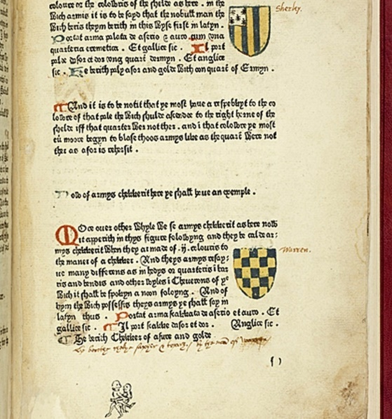
The Boke of St Albans or Book of Hawking, Hunting, and Heraldry by Juliana Berners (1486)
University of Cambridge
This is the most technically difficult book printed in the Abbey Gateway. The book contains text and woodblock images and the third section shows a series of coats of arms in full colour. Colour is also used within the accompanying text to highlight titles and initial letters.
The Boke of St Albans also contains the oldest known list of “collective nouns” including groups you might know like a 'Pryde of Lyons' but also 'a Claterynge of choughes', a 'Dylygence of messengers', and a 'Blaste of hunters'.

A compositor’s job
The compositor was the person who set all of the movable letters of type into a “forme” which could be transferred to the press for printing.
They used tweezers to pick up the tiny metal letters and place them into composing sticks of various lengths to form words. They would also have a chisel for removing any extra metal from the edges of the letters and a key for locking the forme into place once it had been finished.
Tools from St Albans Museums’ collection many donated to the museum by Vic Frost and Roger Shepherd
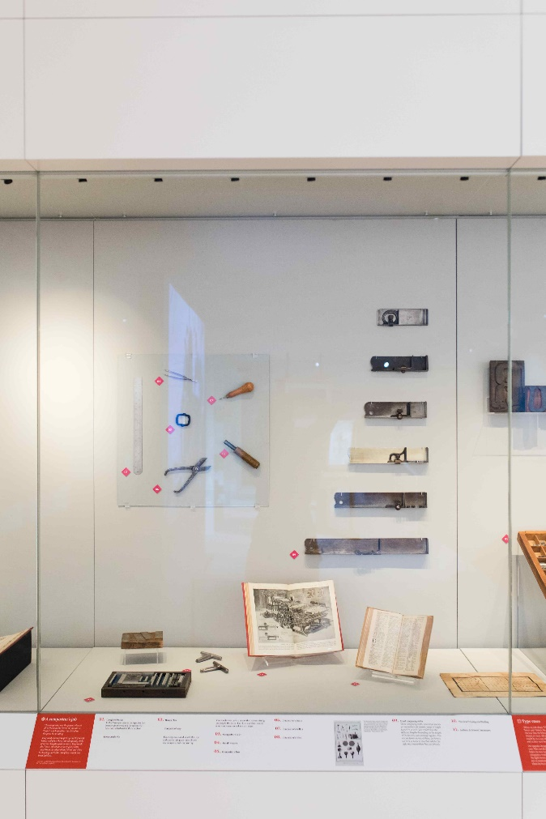
1 Completed forme
In this forme you can see the type that has been set (in reverse) and the spacers that have been added to hold them in place.
Home-made vice.
2 Hempel key
Compositor's key
These keys were used to lock the type and spacers into place once a forme was complete ready for printing.
These tools were used to ensure the type was sitting properly in the forme. The chisel and shears could remove any excess metal or sharp edges.
3 Compositor's ruler
4 Metal tweezers
5 Compositor's lens
6 Compositor's shears
7 Compositor's bodkin
8 Compositor's chisel
Image of tools - 1.6 image of tools (credit Wellcome Collection) (in First Impressions/To Jim)
This illustration shows printers’ tools from the 1700s. Comparing them to the tools in this case which were used in the 1960s and 70s you can see that many stayed the same. The printer’s ink ball in this illustration is also the same as the one in the St Albans crest showing the Schoolmaster Printer from the 1480s.
9 Metal Composing sticks
These composing sticks, sometimes known as compositor’s set squares, range in length from 6 to 12 inches. You would need the different lengths depending on the length of the line you were putting together. You can see letters in one of them, the letters are back to front so that they will be the right way round when they are printed.
10. Practical Printing and Binding
11. Authors' & Printers' Dictionary

Type Cases
When we talk about “UPPER CASE” and “lower case” letters, the names come from the way that the letters were stored in wood frames or cases. All of the capital letters would be in a case above the small letters and so they were known as the upper case.
One popular design of type case was the Caslon case. This was designed to put the most used letters in easy reach of the compositor. A compositor would have to know where to find the right letters without searching each time, just as someone using a computer today learns where the keys on a keyboard are without looking.

Caslon type case with metal sorts
Wooden type case with wooden sorts, labelled size 12 Times New Roman.
To print images, they had to be carved or etched onto a block. This block would then be set into the forme between the lines of text. Large or decorative letters would also be created in the same way.
A selection of image printing blocks
We do not know the books these printing blocks were created for. They show a range of images including a religious scene, a calendar and a musician.
A selection of large letters and numbers
These letters and numbers might have been used for printing posters or to print a large letter at the start of a piece of text.
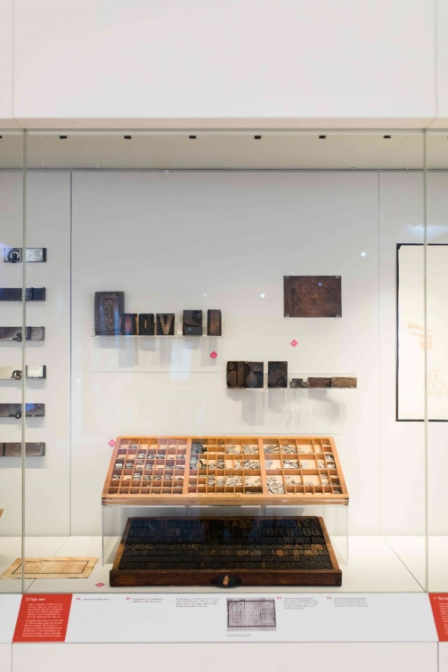

The Lithographic Process
Lithography is a printing process that uses an image engraved on a flat stone or metal plate. A greasy substance is put onto the parts of the image you want to print so that the ink will stick to it. The areas you don’t want to print are made ink-repellent. Using this process, layers of colour can be applied to create complicated designs.
These photographs show the printing presses and stone store at the Dangerfield Printing Company, who were particularly well known for their colour lithography.
Proof prints from the lithographic printing process
Victoria & Albert Museum
These copies of proof prints show the process of printing a six colour lithograph poster. The four prints are from different stages in the process:
Second stone (yellow)
First, Second and Third stones (yellow, green and red)
Fourth stone (black)
First, Second, Third, Fourth and Fifth stones
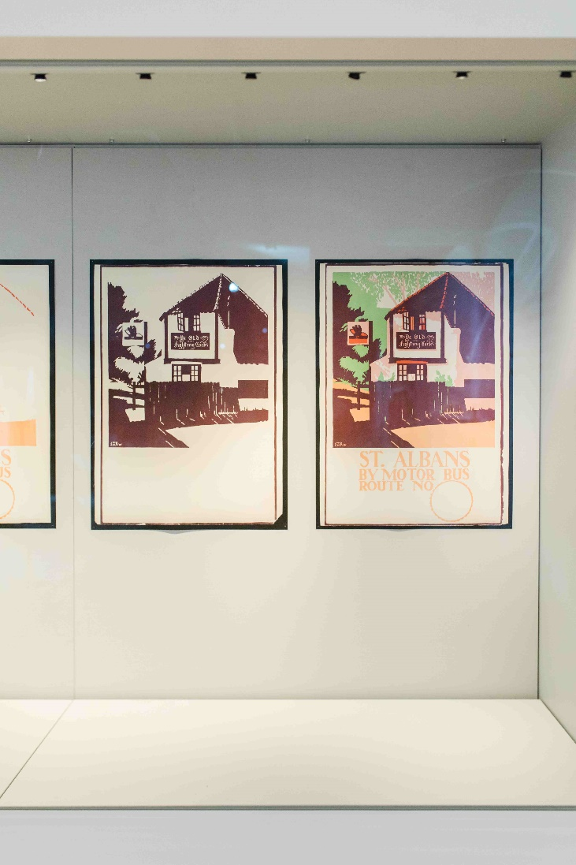
The final poster is an advertisement for the London General Omnibus Company, with a view of Ye Olde Fighting Cocks in St Albans. The poster was designed by Edward McKnight Kauffer who designed many transport posters.

Interactive Activity
Have a go at composing some words from movable type. All the words had to be written back to front so that they would print the right way round.
Can you write your name backwards?

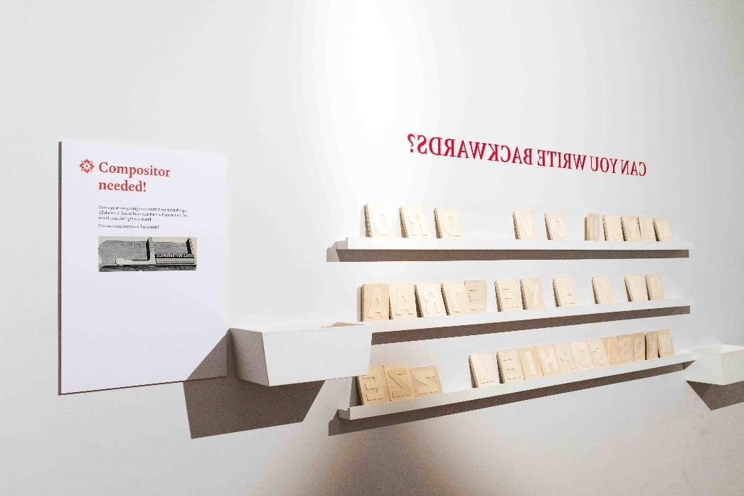

Central Display (large standing pieces)

Replica Caxton Printing Press
William Caxton learned the print trade in Cologne in Germany and brought the technology back to England. Early printing presses were inspired by wine or linen presses which could apply pressure evenly onto a surface. Each page would involve putting together or “setting” movable metal letters into a page of type which could then be printed as many times as you wanted. The press was operated by hand.
Replica created by Hands on History.
Include logo

Arab Treadle Press from Staples Press (1920s)
Although printing press technology continued to improve over the centuries ,this Arab Press invented in 1872, still used the same basic idea as the Caxton Press.
This press was used by Staples until the early 1960s when it was given to St Albans School who set up a Printing Society to produce tickets, programmes and stationery for the school. The press remained in use until the introduction of word processing.
St Albans School
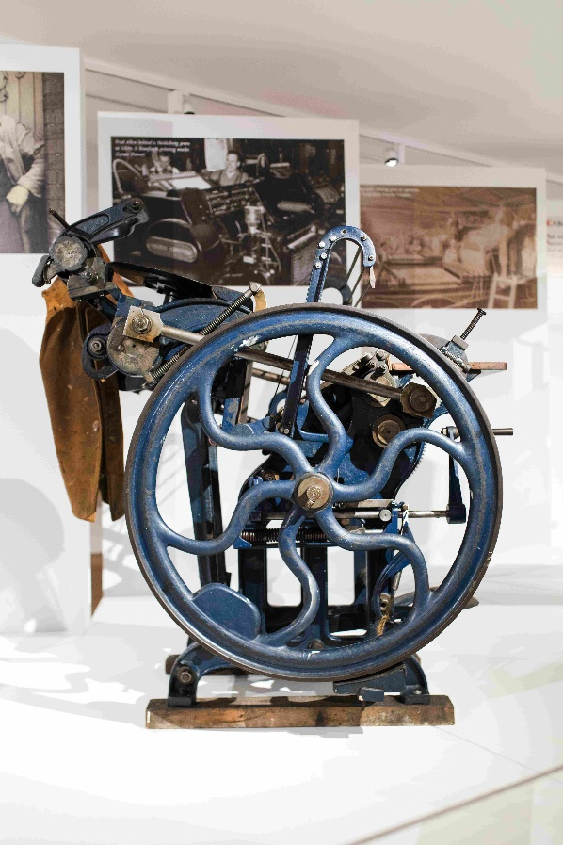
Compositor’s Jacket
This jacket belonged to William Gibbard. He started in the print industry as an apprentice in St Albans before joining the army in 1944. He was given this leather sleeveless jacket whilst he was in the army and wore it throughout his career as a hot press compositor.
Brian Gibbard

3D printer
Printing has moved on a long way from the first presses. This Xnilo V3 printer creates 3D objects in plastic, rubber, ceramics and even chocolate. The printer works by printing a thin layer and then adding more layers until the full shape is created. Almost any shape can be created by 3D printers today from bicycle chains to a fully wearable dress. You could see this 3D printer in operation during the exhibition.
On loan from The Digital Office.

Six images mounted in the gallery wall
- A page from the Book of St Albans printed in the Abbey Gateway in 1486 (University of Cambridge)
- Fred Allen behind a Heidelberg press at Gibbs & Bamforth printing works (Lynne Power)
- Leonard Cheshire and Jack Millard outside Gibbs & Bamforth in their printer’s jackets (Diana Peerless)
- A lithographic printing press in operation at the Dangerfield Printing Company
- The Eversheds printing works on Inkerman Road
- Companies like Digital Office support all kinds of 3D manufacturing like this hand brace

Changing Design

Print designers had to be very skilled and able to create anything from a beautiful poster to a very functional report.

In St Albans, Dangerfield became known for their colour printing and the posters they printed for London Transport, while Eversheds, who took over the factory from Dangerfields, were known for providing calendars and stationery for other businesses. Despite their very different areas of work,, both needed create visually appealing designs that matched the needs of their customers.

Today, the visual look of hand-operated letterpress printing has come back into fashion. Products based around the aesthetic appeal of a well-designed font or simple illustrations can be found in many shops and creating them is becoming a popular hobby.

The craft and skill of print design that was once taught at the St Albans School of Art is now taught at its successor the University of Hertfordshire, alongside newer skills such as 3D printing.

Dangerfield Image
Dangerfield Printing Works opened in a factory on Inkerman Road, St Albans in 1896. Among the firm’s specialities was the printing of large colour advertising posters and lettering transfers for railway coaches, buses and trams. The company had a contract with London Transport and began to produce many of their now iconic posters.

Designing for print
Today companies and individuals can work with designers to layout print using computer programmes and elements can be easily adjusted and presented. Previously, companies used sample books to show off the sorts of designs they could produce.
All of the books in this case were created and used by companies who printed in St Albans.
1. Mr Winter’s scrapbooks of printing
This scrapbook contains examples of the wide range of printing done by Mr Winter. This was a small printing press, but he printed everything from leaflets to business cards and worked with several well-known local companies. You can see his inky fingerprints on one of these pages.
2. St Albans Press House specimens of book type
3. St Albans Press House specimens of circulars
These books were created to help customers select the fonts, sizes and designs they wanted when placing print orders. The first two are from Fisher Knight & Co. and the St Albans Press House was a name used by Gibbs & Bamforth. Each printing firm would have its own selection of fonts available, so depending on the style you wanted you had to select the right firm.
4. Leaves: Type Manual including Glossary of Terms
5. Compendium for printers & buyers of printing
6. Folder of printed logos
These two books were produced by Fisher Knight & Company, they show the different fonts the company used and other symbols that could be printed. The folder was created by Eversheds and contains a wide variety of logos for different businesses from dairies and butchers to stationers and offices. Customers who did not have a logo of their own could use one of these specimen logos.

Form & Function
The printing companies in St Albans produced a wide variety of material that needed to be designed and laid out. Balancing text in a document or a newspaper is an important skill and in this case you can trace the development of design from the simple text of Solomon George Shaw’s printing to the colourful designs of Eversheds’ headed papers.
1. First edition of the Herts Advertiser (printed by Gibbs & Bamforth)
The first edition of The St Albans Times and Herts. Advertiser came out on Saturday 7 July 1855. It cost one-and-a half pence and contained eight pages of national news (including an account of the Crimean War) which was brought from London by stagecoach for setting in St Albans. The first edition consisted of 300 copies produced on a hand-operated press.
2. A list of all the estates and benefactors belonging to and conferred on the church and parish of St Peter (printed by Solomon George Shaw)
3. Eversheds Promotional booklet calendar range 1987
4. Price list for R.A Ashby
5. Mid Herts election postcard for Hon. Vicary Gibbs, 1904 (printed by Richardson)
6. Headed paper letter to H Green (printed by Fisher Knight & Co.)
7. Address label with "Printed matter" (printed by Fisher Knight & Co.)
8. Salvation Army Christmas cards (printed by Campfield)
9. Hermes Magazine, Napsbury Hospital
Patients and staff worked together to produce the Hermes Magazine at Napsbury Hospital. They wrote the articles, drew pictures and then printed and bound the copies in the hospital’s own print room (pictured here).
10. Drivers' Record book
11. Lard and dripping bag samples
12. Eversheds’ own business cards and stationery
13. Book of Pass Book sample pages
Companies like Eversheds worked with many different businesses. They had to print onto a wide range of materials from paper and card to a lard bag. They also had to create designs that worked with their brands and looked attractive to customers. The variety of logos, fonts and colours available to their customers was huge.
14. A variety of headed note paper for St Albans’ businesses printed by Eversheds

Printed in St Albans
Books printed in St Albans cover a huge range of subjects and topics, each designed in its own unique way. Some smaller printing companies worked with very simple designs but larger companies like Dangerfield had the ability to create an embossed cover for their book In the Footsteps of the Conqueror.
All of the books in these two cases were printed in St Albans.

1 Chatting Now & Then, Key in Love, Sun and Shadow (two copies) by Patricia Ball printed by W.A. Brisco
2 The Story of Salisbury Hall by Sir George Bellew (Fellowship Printing Company London Colney)
3 St Helens Wheathampstead by Ruth Jeavons (Heathprint Ltd)
4 Footpath Walks Around St Albans, 1972 (Penna Press)
5 Footpath Walks from London Colney (Albanian Press)
6 In the Footsteps of the Conqueror, 1909 (Dangerfield)
7 In Debt to Christ by Douglas Webster (StaplesPress)
8 St Albans Lodge N2786 (Richardson)
9 The Saturday Book edited by Leonard Russell, 1947 (Mayflower Press)
10 Observations on a particular kind of Scarlet Fever that lately prevailed in St Albans by Nathanael Cotton
11 Victorian Byeways by Vera M Snelling (Staples Press)
12 Responsive Services for Children's Worship (Campfield Press)
13 Exhibition of Embroidery and Vestments St Albans Cathedral 1980 (Campfield Press)
14 Parish Church of St Etheldreda, Hatfield (printed by Campfield Press)
15 Hertford Past and Present 1981 (Campfield Press)
16 A Puffin Quartet of Poets: Eleanor Farjeon, James Reeves, E.V.Rieu, Ian Serraillier (Campfield Press)
17 Science News 29 published by Penguin Books, 1953 (Campfield Press)
18 Cottage Life in a Hertfordshire Village (Campfield Press)
19 Notes on Stevenage and Baldock, 1830 (Gibbs & Bamforth)
20 Early Associations and Recollections by Rev Henry Smith, 1886 (Gibbs & Bamforth)
21 Aldenham Church Parish Magazine, 1915 (Cartmel & Sons)
22 Congregational Church Centenary Memorial 1894 (Gibbs & Bamforth)
23 Aucassin and Nicolete by Michael West (Campfield Press)
24 The Brave Gay Road by George Graveley (Cartmel & Sons)

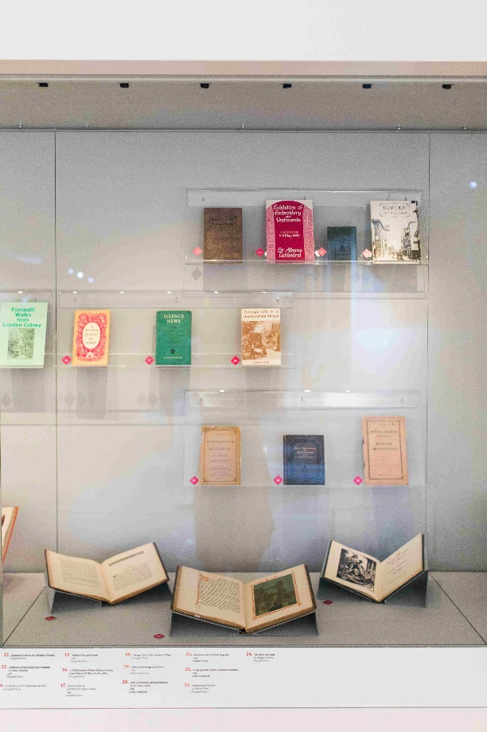

The quest for perfect design
Frederick Sander was known as the ‘Orchid King’. He was passionate about orchids and ran a plant nursery in St Albans with over 60 greenhouses. It is estimated that his nursery sold over 1,000,000 plants in the 1880s and 1890s.

Sander’s greatest project was to create the Reichenbachia, the ultimate book on orchids named in honour of German orchidologist (an orchid expert) Gustav Reichenbach. The pictures, by illustrator Henry George Moon, are life-size and correct in all their detail. Sander wanted his books to be perfect and so he installed his own lithographic printing press allowing him to control every aspect of the process.

The quality of the finished volumes was incredibly high but the cost of the project was also enormous and Sander said that the process almost ruined him.

Reichenbachia
Royal Botanic Gardens, Kew
This volume is the second series which was released in 1892. Each volume is 54cm tall and weighs over 20kg. The cover is leather and Sander personally chose paper of the highest quality for the pages.

Words and pictures
Campfield Press, the Salvation Army Printing Works, were based in Fleetville on Campfield Road. Alongside the Salvation Army’s own printing needs they also produced books for other publishers.
Everyman: A Morality is one of a series books illustrated by Ambrose Dudley and printed by Campfield Press. Other books in the series included The Dudley Portfolio of The Pilgrim’s Progress and The Prologue to the Canterbury Tales. Dudley not only illustrated the tales but also designed the books.

Everyman: A Morality Play
This was written around 1500 by an unknown author. Ambrose Dudley’s edition includes his own woodcut illustrations.

Changing Industry

When the Schoolmaster Printer started printing in the Abbey Gateway he was a skilled craftsmen, working with one printing press and probably a small team of assistants.
400 years later Gibbs & Bamforth started printing in St Albans from the Clock Tower, another small historic building, with a single printing press. Many of the printers in St Albans in the 1800s were small businesses, but 100 years later individual print companies were growing quickly.
The new, faster printing presses using gas and then electricity were much larger and so companies that had operated in the centre of cities like London moved out to areas such as Fleetville in St Albans, for more land and light.
As the companies grew, the traditional set-up of a master printer and his apprentices developed into larger “chapels”, later becoming trade unions. Until recently these trade unions allowed print workers to control who joined the industry and to protect their rights as emloyees.
Map & Key
Printing Presses in St Albans
This map shows the location of just a few of the printing presses that have operated in St Albans since 1479. They show the spread around Fleetville and the city centre but there were many more across the city and district.
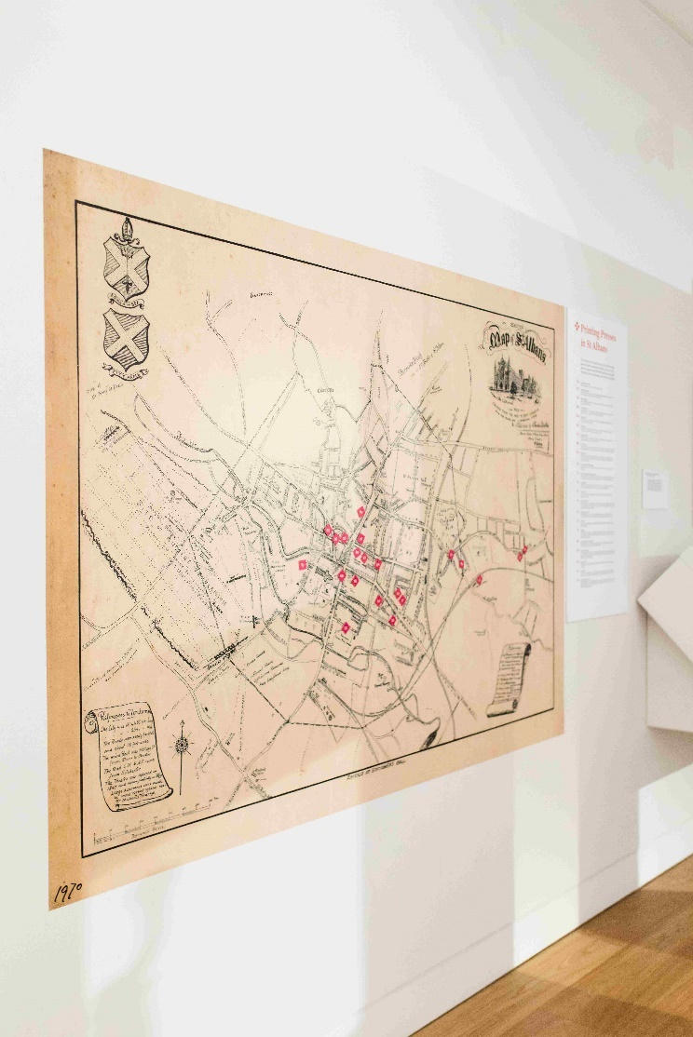
- The Schoolmaster Printer
The first printing press in St Albans was in the Abbey Gateway.
- Solomon George Shaw
Shaw was a Printer in the early 1800s. During his life he owned printing presses in both Hertford and St Albans and is buried in St Andrews Churchyard, Hertford.
- Gibbs & Bamforth
Gibbs and Bamforth were printing in St Albans from the early 1820s until the 1970s. They founded the Herts Advertiser.
- W Cartmel & Sons
Three generations of the Cartmel family printed in St Albans. William started the firm in 1878 and it was then run by his son George, followed byGeorge’s daughter Dorothea.
- George Stevens
George Stevens started printing in Upper Dagnall Street in 1882. He died in 1896 but his wife continued the business until 1914.
- Stabo Aston
Aston printed The St Albans’ Clock Tower & Gazette in the 1890s. They advertised as printing “at the lowest prices on the shortest notice, in the best style.”
- The Misses Randall
Elizabeth, Mary and Kate Randall were stationers and booksellers who started printing in the 1890s at the same address as H.A. Richardson (below).
- H.A. Richardson
Richardsons were printing in St Albans from the 1890s until the 1970s. During that time they printed a lot of material for the Diocese of St Albans including over 30 million copies of their newsletter.
- School of Arts
Although the School of Arts wasn’t a commercial printer, printing was one of the subjects they taught and many printers, professional and amateur, passed through the school during its 80 years in Victoria Street.
- The Dangerfield Printing Company
Dangerfield are best known for the colourful posters they printed for what is now Transport for London.
- Smiths Printing and Publishing Company
Smiths named their print works the Fleet Works after Fleet Street in London. Although the company only traded in St Albans for 25 years, their name lives on in the street names in the area they printed in, Fleetville.
- Campfield Press
Campfield was the printing works for the Salvation Army. They were printing in St Albans for 90 years, producing work for the Salvation Army and other commercial customers.
- Victoria Press
The Victoria Press was printing during the 1920s & 30s. They printed the early editions of the Harpenden Free Press newspaper.
- Fisher, Knight & Co
Fisher, Knight & Co were founded in 1926 in Harpenden. They moved to Lattimore Road in St Albans in 1930. Eventually they merged with another company and became Flarepath Printers, operating from the old Handley Page aircraft manufacturing site near Radlett.
- Whitehall Garden Press
Whitehall Garden Press was run by Van and Wilkie Winter, the sons of artist Holmes Winter. In 1945 Wilkie Winter moved on to found the Fellowship Printing Service in London Colney.
- J.W. Vernon
J.W. Vernon printed from 1923 to 1960 in a building which had been built as the social club for Smiths Printing Company.
- Eversheds
Eversheds came to St Albans in 1940 after their printing works in London were bombed. They took over the premises of the Dangerfield Printing Company and expanded to fill the area between Alma Road and Inkerman Road.
- The Mayflower Press of Plymouth
The Mayflower Press were another company displaced by wartime bombing raids. They printed in St Albans between 1941 and 1947 when they moved to Watford.
- St Albans Typesetters
St Albans Typesetters provided services for several local printing works including Richardsons. They would set the letters and words into their metal formes which would then be taken to the different companies to be printed.
- Albanian Press
The Albanian Press was registered as “general printers, bookbinders and stationers” and operated in the 1950s.
- W.A. Brisco
W.A. Brisco is an example of one of the many small printers who operated in St Albans during the twentieth century. He started in Stanhope Road in 1965 and was still printing in the early 2000s.
- Jetspeed Printing Services
Jetspeed Printing Services started in College Street in 1967 before moving to Belmont Hill. They moved to Harpenden in 1988 and are still printing today.

Wall Display
Gibbs & Bamforth
(printing in St Albans 1824 – c.1970)
In 1824 the Gibbs family leased the Clock Tower and started a printing business. By 1837 Richard Gibbs had moved the business into the Tudor Town Hall (now a stationers). The company became Gibbs & Bamforth in 1871 when John Bamforth joined.
By 1900 it had expanded behind the old Town Hall building, buying the old Methodist Church in Dagnall Street. Having started with hand-operate presses such as the Stanhope, the company now had room for larger presses. In 1929, Gibbs & Bamforth installed a new six-reel electrical-driven Hoe Rotary Press which had the capacity to produce 26,000 sheets per hour.
Gibbs & Bamforth are best-known for founding the Herts Advertiser newspaper. Its first edition, called the St Albans Times and Hertfordshire Advertiser, was printed by Richard Gibbs in 1855.
Printing continued in Dagnall Street until 1970 when the property was sold, but the Herts Advertiser continues as a local newspaper to this day, now part of the Archant Group.
Did you know?
During the Second World War, Alec John Galbraith Gibbs was asked to prepare a “fake” copy of the Daily Telegraph reporting that Hitler considered his deputy, Rudolph Hess to be “a lunatic”. This was part of an elaborate plot to get Hess,(who was at the time being held prisoner at Woburn Abbey), to talk to the Political Intelligence Department. In total, Mr Gibbs supervised the production of a staggering 1,250,000,000 newspapers, propaganda sheets and false documents as well as inventing a special printing press that could be dropped by parachute and used by resistance fighters.
Smiths Printing and Publishing Company
(printing in St Albans c1897 - c1923)
Smiths Printing and Publishing Company was founded in London in 1891. Expanding rapidly, the company bought ten acres of land on Hatfield Road in 1897. The new Fleet Works opened in 1899 giving the area its name - “Fleetville”, echoing the long printing history of London’s Fleet Street.
Smiths printed on four American ‘Century’ presses made by the Campbell Company of New York. One of the factory’s most important features was that it was all on one level, with a tramway running the whole length of the building.
Thomas Smith, the head of the firm, placed great importance on his staff’s wellbeing and, alongside the factory, built houses, a social club and allotments for them. These houses still stand in Fleetville on Bycullah Terrace (named after his house) and Arthur Road (named after Smith’s director Arthur J. Hall).
Smiths closed in 1923. The site was taken over by Howard Grubb and Sons, astronomical instrument makers and then by the Ballito Stocking Company before becoming a supermarket.
Did you know?
Smiths were known for the quality of their colour printing. They printed catalogues for many horticultural companies and the souvenir programmes for the 1907 St Albans Pageant.
Campfield Press (Salvation Army Printing Works)
(printing in St Albans 1901-1991)
In 1901 the Salvation Army Print Works needed to move out of London to a larger site. They purchased a factory on Campfield Road in St Albans which had been owned by Smith Orford Limited who had been printing here since 1895.
The factory site they moved into was already called the Campfield Works and so in 1915 the company was renamed the Campfield Press. At first, the press mainly printed Salvation Army material; including the War Cry newspaper, but they soon expanded to take on jobs from other companies.
Many of the books printed by the Campfield Press include beautiful text and illustrations. The illustrator Ambrose Dudley worked with them on several books including The Pilgrim’s Progress and Everyman.
In 1991 the Salvation Army decided to close the works as they could no longer afford the repairs to the building. The employees - some of whom had worked for the company for over 40 years - were only given one week’s notice of the closure.
Did you know?
A special siding and covered landing stage were built on the Great Northern Railway branch line behind the factory to make it easier to transport and receive goods. You can still see the site of the Salvation Army Halt on the Alban Way.

The Dangerfield Printing Company
(Printing in St Albans c1896 – c1940)
Frederick Dangerfield built his factory on Inkerman Road, St Albans in 1896. It was at the time the most modern lithographic plant in England and one of the first factories to use the “northern lights” system, where glazed north-facing sloped skylights provided the light needed for the printing process. This created a distinctive zig-zag roof shape.
Among the company’s specialities was the printing of large colour advertising posters and transfers for lettering for railway coaches, buses and trams. The company had a contract with London Transport and began to produce many of the now iconic posters.
During the First World War many printing companies closed because of the loss of their predominantly male work force into the armed forces. By 1916, Dangerfield had lost 80% of its workers to the war effort. Their attempt to train female staff to take over some of these roles was blocked by a print union.
The company survived the war and was bought out by Eversheds in 1940.
Did you know?
In December 1916 Frederick Dangerfield was reported as saying that his business was no longer making a profit and his only aim was “to carry on until his two [sons] came back to enable them to carry on.” He said that without his sons he would “chuck it” tomorrow.
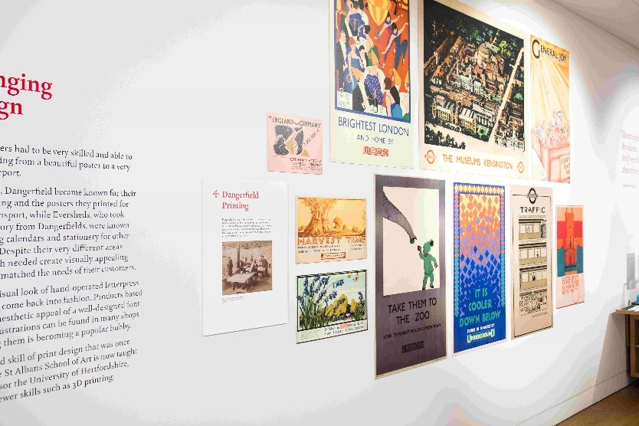

Eversheds
(Printing in St Albans 1940 – late 1990s)
Eversheds was founded by Joseph Eversheds in London in 1876. It was a successful company, providing printing services for a wide range of businesses, employing over 200 people by 1939. In September 1940, the Eversheds factory in Bow, East London was destroyed by a bomb. The company’s sales manager Fred Eversheds was killed in a separate raid at around the same time and the decision was taken to relocate.
Eversheds found their new premises by buying the Dangerfield Printing Company in St Albans. They also used a large house, Westminster Lodge, as offices.
In 1955 Eversheds opened a new building on their Alma Road site; it was one of the first buildings to be built using a system of reinforced concrete beams. The company continued to print there until the late 1990s.
Did you know?
Despite the bombing in London, there was only one week in 1940 when Eversheds fully stopped production. The company was supported by others in the business and was able to salvage some of its presses from the ruins of the Bow factory.

Printing in the High Street
More than 100 printers operated in St Albans between 1800 and today. Some were a single printing press being operated from a house and some were huge companies with hundreds of employees.
In the High Street alone, we have identified at least nine different printers. In 1841 Robert Johnson was listed in local trade almanacs as a printer based on the High Street. but over the next 40 years there were also the Misses Randall, W. Langley, Randall & Co and Thomas Pollard.
A printing press could be set up in the back of a shop or the garden of a house so that businesses like the Randalls who were originally stationers and booksellers, could also print their own works.
Did you know?
Printing in the High Street continued right up until the 1970s with Richardsons who operated at 5 High Street, before the building was split between a restaurant (where the compositor’s room had previously been) and a shop.

Wall Cases
Working Life
To work in the print industry before the 1980s you had to be a member of a trade union, such as the National Society of Operative Printers and Assistants, National Union of Printing and Paper Workers or the Typographical Association. You would also have probably served as an apprentice, learning on the job starting with the simple tasks before becoming more skilled.
Magazines and newsletters were produced by trade unions and individual companies with industry updates, company news and details of social activities.
In the 1980s industrial disputes in Fleet Street, London led to the end of several print trade unions. Although most of the large print companies had moved out of St Albans by that time, there were still many print workers living in the city.
Items:
- Staples Press Limited magazine 1951 and 1952
- Campfield Courier volume 17 and 22 (1949)
- Typographical Association membership cards belonging to Roger Shepherd

- Apprentice Indenture papers - This contract belonged to Vic Frost. He was apprenticed to JW Vernon in Fleetville from 1932 – 1939. Print apprentices were sometimes known as printer’s devils, possibly because of the black ink that would get all over their hands and clothes. An apprenticeship usually lasted 7 years. Apprentices were usually the youngest member of staff in a company and were often the victim of jokes or pranks by the older printers.

Working at Eversheds
Before Eversheds moved to St Albans in the 1940s, they ran trips for their employees to places such as Windsor and Epping. They worked to recognise longstanding employees and set out awards to be given in their staff booklet. In 1962 they also launched their own in-house magazine. It was originally called the Company News Summary, later becoming known as the Proofreader.
Four generations of the Evershed family worked in the family business, starting with Joseph Evershed and finishing with Mark Evershed, who graduated from the London School of Printing in 1963.
Items:
- First Eversheds newsletter 1962
- Three editions of the Proofreader (1980s)
- Eversheds Staff Booklet
- Copper alloy plaque presented to directors of Evershed
- Eversheds Memorial Tribute to Norman Evershed 1910-1983
- National Scheme for the Employment of Disabled Men Certificate - This certificate was issued to J Evershed & Co. Ltd and Dangerfield Printing Co. Ltd in 1943 to certify that they had employed an approved percentage of disabled ex-servicemen. Schemes like this existed to ensure that soldiers who had been injured during the Second World War had employment to return to.
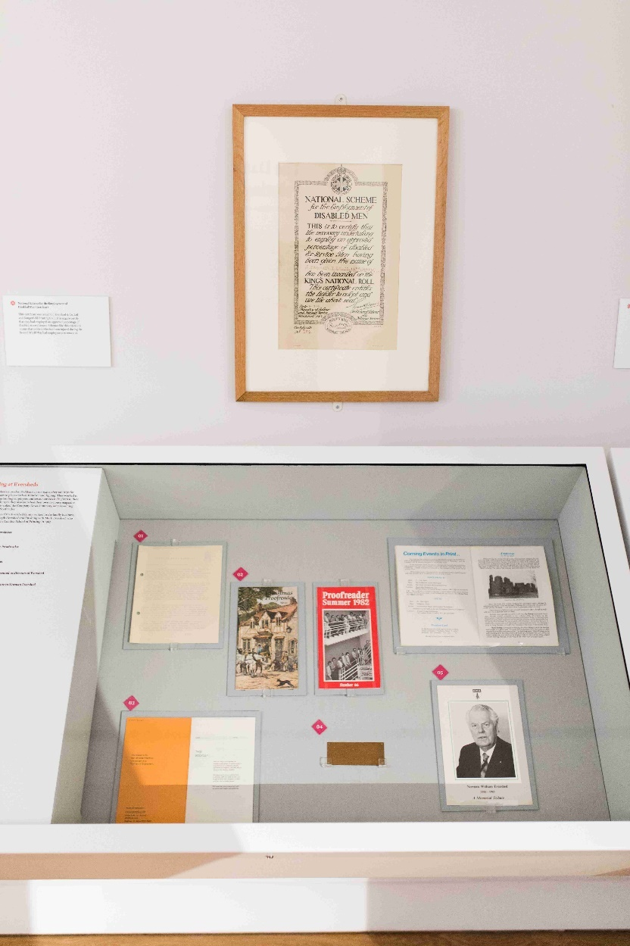

Interactive Embossing stamp station

First Impressions Seal of Approval
Put a piece of paper into our embossing press and pull down the handle to create a raised image to take home with you.
Or, stamp one of our feedback cards and tell us what you discovered today. Post your feedback card into the slot and we will display a selection of them above.
How it works
An embossing machine like this one works in a similar way to a printing press. There is an etched plate inside the press. In a print press you would put ink on this plate to mark the paper but with an embossing machine you press the design onto the sheet.

