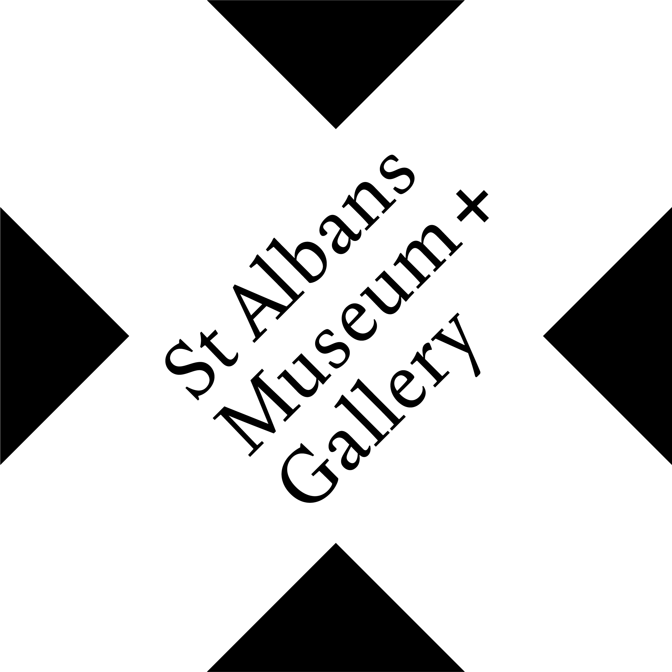
Lockdown Life in St Albans
How has your community group experienced lockdown life in St Albans? Joanne Ling & St Albans Museums want to hear from you.

Living through the Covid Pandemic is the biggest challenge faced by the people of St Albans for over seventy years and has undoubtedly had an impact on every individual and community group living in St Albans. This exhibition will provide local community groups across St Albans the opportunity to share their experiences from when the lockdown was first enforced on the 26th March 2020 in a creative format. This exhibition will be a time for everyone to Pause, Reflect and Gain Awareness of the different communities within St Albans highlighting their resilience and positivity during Lockdown.
We’d like to hear from community groups in their own words what Lockdown Life has meant for you and we will be bringing the responses together in the Assembly Room at St Albans Museum + Gallery in Spring 2021.
Submissions can include: photographs, writing, artwork, sculpture, recordings or film. At this stage we would like to hear from your group what your experience has been and how you would like to share it with St Albans.
If you would like to share your Lockdown Life with us please return the completed form with up to three images to Sarah Keeling by Friday, 19 February 2021
museum@stalbans.gov.uk (with Lockdown Life in the subject line )
or by post to:
FAO Sarah Keeling, St Albans Museum + Gallery, Town Hall, St Peter’s ST, St Albans AL1 3DH

If you have any questions or require creative professionals such as a photographer or an artist to help put together your submission, please speak to Joanne Ling at jolingmojo@hotmail.com and we will try to see how we can help.

Pandemic Portraits
In parallel and as part of this exhibition, Nic Madge, a photographer based in St Albans, is running a PANDEMIC PORTRAITS project. For that project, he is photographing St Albans residents both with and without their Covid-safety masks and noting their brief comments about the Pandemic. Please contact Nic by email at nicmadge@ntlworld.com if your community group would like him to photograph members as part of the project.

Your name& Community Group Representing

Contact Details: Address, Tel and Email

Biographical note of the Community Group represented (100 words max) which the Museum can use in the exhibition:

What has Lockdown Life been like for your group? (200 words max)

What would you like to share (photo, montage, writing, artwork etc. please include any dimensions and, if a 3D object, practicalities for display)

Terms & Condition
By sending us your text submission, you hereby assign to the Museum all copyright in your contribution for use in all and any media. You understand that this will not affect your moral right to be identified as the ‘writer’ in accordance with the Copyright, Design and Patents Act 1988.
A selection of submissions will be chosen to display at St Albans Museum + Gallery as well as on the museum website. They may also be added to St Albans Museums’ archive as a lasting memory of Lockdown.

Signed _____________________ Date ___________________

